Experts by Experience Reference Group Proposal Paper
North Central London Mental Health Programme

Contents
Document Control 1
Experts by Experience Reference Group Proposal 2
1. Our Vision 2
2. Principles 2
3. Starting Point 2
4. Our Promises 3
5. Principles of the Reference Group 3
6. Recruitment of the Reference Group 4
Appendix 1 – Draft Terms of Reference 5
Appendix 2 – Draft Code of Conduct 7
Appendix 3 - Existing Engagement Networks 8
Appendix 4 - Role Description and Person Specification 9
Appendix 5 – Recruitment Process 11

Experts by Experience Reference Group Proposal

1. Our Vision
- The overarching vison on the NCL Mental Health Programme is: “We will work with individuals and communities to build a model of care and support that enables our population to live well.”
- In order to deliver this vision we will work with experts by experience to inform the shaping of the programme’s workstreams; along with commissioners, providers, the voluntary sector and other stakeholders.

2. Principles
Effective involvement should be grounded in a set of principles to ensure involvement is meaningful and not tokenistic. These principles are:

- The contribution of experts by experience is valued on an equal basis to those of clinicians and managers.

- Every effort is made to organise work in ways in which does not exclude experts by experience, for example through the use of jargon.

- Appropriate remuneration is provided for those experts by experience who are asked to make a substantive contribution to the work.

- Necessary support is provided for individuals to ensure they can play a full part in activities.

3. Starting Point
- The Sustainability and Transformation Plan (STP) process, which the NCL Mental Health Programme is part of, has been happening at considerable pace and has not, totally, been in the control of local organisations. Two helpful stakeholder workshops, involving representatives of service users and carers, have been held as part of the development of the mental health components of the STP. It is recognised that this has not represented a sufficient level of involvement in the development of the plan.

- At the last stakeholder event the 3 Provider Chief Executives undertook to take back the issue of expert by experience involvement to the Mental Health Steering Group, and to consider options for future involvement in the programme by service users and carers. On 14th June 2016 the Steering Group agreed to recruit an Experts by Experience Reference Group for the NCL Mental Health Programme. This Group will offer feedback and input into the development of the programme, with representation sitting on the Steering Group.

4. Our Promises
- We will involve experts by experience in decisions on mental health services within the NCL Mental Health Programme – seeing them as equal partners with commissioners, providers and other stakeholders. We will endeavour to involve people at the earliest opportunity, and if this is not possible – or involvement is not appropriate – we will be transparent about the reasons for this.

- We will always share information about service changes, developments and NCL STP plans. This will be both feeding back to those who have been involved, and sharing information with the wider service user and carer community.

- We will treat experts by experience as individuals and colleagues, and constructively challenge any discriminatory or stigmatising behaviour when we see or hear it.

- We will take various approaches, and give different opportunities, for experts by experience to be involved in the design, commissioning and evaluation of services. In doing this we will realise that we should, within reason, be adaptable to everyone’s style of working – and not expect people to adapt to us.

- We will work to engage and discuss with people to whom specific projects may be relevant - understanding that experts by experience are not a homogenous group.

- We will advertise inclusively and go through a fair process to choose the best candidate(s) where there is a need for one or two service users/carers to have a leadership role.

- We will reward and recognise experts by experience for involvement including creating paid opportunities where appropriate.

- We will endeavour to provide training and/or support when is necessary for someone to contribute. If in a leading role any experts by experience involved will be always be offered supervision and support.

- We will be honest and transparent about our own, individual and collective, limitations – in terms of authority, budget, time etc. – when it comes to decision making.

- We will be open minded and searching in a constant evaluation of the way we engage service users and carers, willing to hear constructive criticism and concern even when it is directed towards us.

5. Principles of the Reference Group
- The Group will be recruited to ensure a wide range of views are represented. However, it is acknowledged that the members of this Panel will not be able to represent all views of service users and carers.

- The Group will report into the NCL Mental Health Programme Steering Group, offering feedback and input into the development of the programme.

- The Panel will link in with existing engagement streams across NCL and support wider communication and consultation, such as: development of clear and accessible communication materials, the use of surveys to secure service user and carer feedback, further stakeholder workshops, and use of existing engagement networks.

- Remuneration
  - For non-generic activities such as co-production and project governance £12.50 per hour will be paid to members of the Experts by Experience Reference Group
  - For generic activities, such as general stakeholder workshops, travel expenses will be paid
  - Where payment is made above expenses, the individual will be responsible for declaration of income for tax and benefit purposes

6. Recruitment of the Reference Group
- The Reference Group will be recruited using existing networks from within the Trusts and across the boroughs

- Up to 15 experts by experience will be recruited to the Reference Group, with equal representation from each of the NCL boroughs

- The Reference Group will be supported by the Trusts existing arrangements for expert by experience engagement

- The Reference Group will follow a Terms of Reference (Appendix 1), and will abide by a Code of Conduct (Appendix 2)

- Membership will be reviewed every 12 months

Appendix 1 – Draft Terms of Reference
NCL Mental Health Programme Reference Group Terms of Reference

1. Introduction
These Terms of Reference set out the membership, remit and responsibilities of the NCL Mental Health Programme Reference Group.
2. Purpose
The Reference Group brings together representatives from across Barnet, Camden, Enfield, Haringey and Islington, who have experience of mental ill health, including service users and carers, to offer feedback and input into the development of the NCL Mental Health programme, with representation sitting on the Steering Group.
DRAFT
3. Membership
- The Reference Group will consist of a maximum of 15 experts by experience from across NCL
- Where possible, this will consist of equal representation from each of the NCL boroughs
- Membership will be reviewed every 12 months
4. Chair
- The Reference Group will elect a Chair to chair the Group for a period of time agreed by the Group
- The elected Chair will be the lead representative of the Reference Group to the Steering Group for the period that they hold the position of Chair
5. Secretary
The Reference Group will be supported by a member of the NCL Mental Health Programme team who will manage the agenda, papers and take meeting notes.
6. Quorum
The Group must be representative of North Central London and will therefore include:
- Representation from 3 of the 5 NCL boroughs
- 1 x service user
- 1 x carer
7. Frequency of Group Meetings
- Meetings will be scheduled every one to two months depending on workload

- Where needed, meetings may be scheduled more frequently to fit in with the Sustainability and Transformation Plan Process
8. Notice of Meetings
Meetings of the Reference Group may be called by the Chair or the Steering Group. Unless otherwise agreed, notice of each meeting together with an agenda of items to be discussed and supporting papers will be sent to each member no less than seven days before the date of the meeting. The notice shall confirm the time, date and place of the meeting. Meeting location may rotate across the NCL boroughs, using venues with good transport links.
9. Duties
- To offer feedback and input into the development of the NCL Mental Health Programme
DRAFT
- To link in with wider engagement networks across North Central London, supporting wider communication and consultation of the NCL Mental Health Programme
- To develop particular areas of work as agreed by the Steering Group. Initial areas of work include:
  - Establishing consistent communication methods with wider networks across NCL
  - Partake in visits with Steering Group members to areas which are seen as good for particular service areas
  - Propose a new name for the programme
  - Provide feedback on workstreams and input into the development of workstream outcomes, with an initial focus on primary care mental health
10. Authority
The Reference Group is accountable the NCL Mental Health Programme Steering Group
11. Conflicts of Interest
- The Chair shall manage actual and potential conflicts of interest to ensure that decisions are made and are seen to be made in an open and transparent way in the best interests of the organisation and the public. Decisions must be taken and seen to be taken with integrity and without being unduly influenced by private interests.

- Any conflicts of interest shall be dealt with in accordance with x Conflict of Interest Policy (policy used to be confirmed).
Review
These Terms of Reference shall be reviewed annually.
Ratified Date:
By:
Review Date: Annual

Appendix 2 – Draft Code of Conduct
Code of Conduct for the NCL Mental Health Programme Reference Group
Personal Conduct
- Promote equality and diversity by not discriminating unlawfully or unfairly against any person

- Treat all members, staff and guests with respect

- Not use any racist, sexist or homophobic language

- Not make derogatory, inflammatory or personal remarks about other people
DRAFT
- Welcome new members and make them feel comfortable in meetings, workshops, events and conferences

- To respect the views of other members of the Reference Group

- Not to speak or write on behalf of the group without the prior agreement of the group. Make any correspondence sent on behalf of the group available to all members of the group.
Conduct of Meetings
- Arrive punctually to enable meetings to start promptly

- Switch mobile phones to silent during the meeting

- Work with other members constructively to arrive at the best possible solution to the matter under discussion

- Keep contributions brief and to the point

- Listen to each other and allow each other the opportunity to speak and comment. Respect the views of others and their right to speak. Avoid jargon or explain what it means

- Remember that this Group is a representative group for a much wider group of people, therefore to try and ensure a wide range of views are considered

Appendix 3 - Existing Engagement Networks – needs review
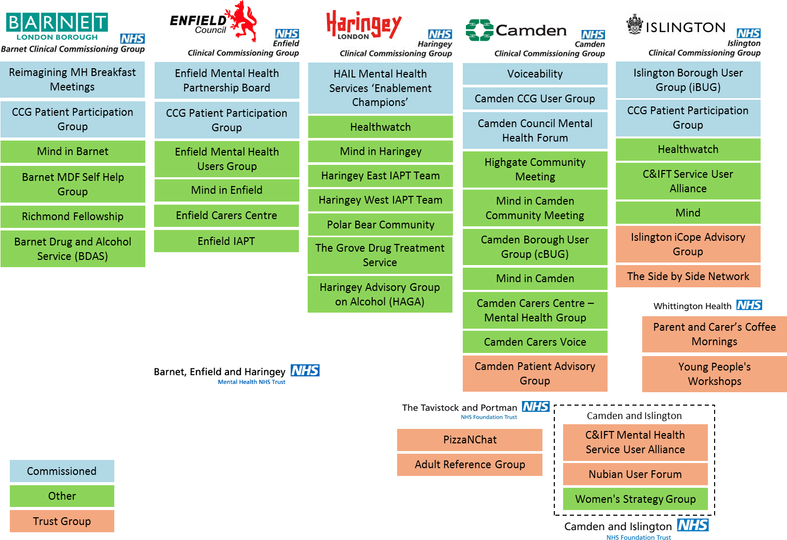

Appendix 4 - Role Description and Person Specification
NCL Mental Health Programme Expert by Experience Role Description and Person Specification
Title: Expert by Experience
Supported by: NCL Mental Health Programme Team
Hours: Ad hoc
Post length: 12 months, may be extended on review
Main tasks:
- Participate and give input in the NCL MH Programme Experts by Experience Reference Group Meetings
- Participate and give input in some of the programme Steering Group Meetings
- Participate in workshops
- Support the development of wider service user and carer engagement for the programme
Person Specification
Specification | Essential | Desirable
Personal Qualities | - Demonstrate an understanding and commitment to improving mental health services  - Ability to reflect on own experiences  - Commitment to parity of esteem  - Ability to be sensitive to a wide range of viewpoints and seek consensus.  - Ability to understand and empathise with the impact of mental illness  - Ability to understand and maintain appropriate boundaries | - Open to being challenged in regard to their knowledge and life experience.
Experience | - Experience of mental ill health either personally or someone close to you | - Experience of contributing to co-production
Skills | - Conducts self in a mature and responsible manner  - Reliability and integrity  - Ability to deal with potentially stressful situations  - Flexible/adaptable  - Willing to work in teams and ability to work well and participate in groups  - Capacity to work within established policies and procedures, including confidentiality and equal opportunities
Knowledge and Understanding | - An awareness of mental health services

Benefits
- References given
- Opportunity to contribute to the improvement of mental health services in North Central London
- Opportunity to meet new people
- Opportunity to develop interpersonal skills
- Travel expenses
- Remuneration of £12.50 per hour will be paid for co-production work. This excludes contribution at general stakeholder workshops but includes contributions to specific areas of work as agreed by both the Steering Group and Experts by Experience Reference Group, such as expert by experience representation on the Steering Group, and delivering particular pieces of work on behalf of the Steering Group.
Additional Information:
Confidentiality: Attention is drawn to the confidential aspects of this role and personable responsibility and liability under the Data Protection Act 1998. Matters of a confidential nature, including information relating to service users, colleagues or staff, must not under any circumstances be divulged to any unauthorised person.
Health & Safety: The post holder is required to take reasonable care of their own health and safety and that of other people who may be affected by their acts or omissions at work and to ensure that statutory regulations, policies and codes of practice and departmental safety rules are adhered to.
Equal Opportunities Policy Statement: We believe that equality for all is a basic human right and actively oppose all forms of unlawful and unfair discrimination. We celebrate the diversity of society and are striving to promote and reflect that diversity within this group.

Appendix 5 – Selection Process
NCL MH Programme Experts by Experience Reference Group Selection Process
October- November 2016
December 2016
Late Nov to early Dec 2016
Late November 2016
October 2016

